CSA1708-ARTIFICIAL INTELLIGENCE
LAB EXPERIMENTS
Program 16 : Python Program to Implement Feed Forward Neural Network
Aim
To develop a Python program to implement a Feedforward Neural Network (Multi-Layer Perceptron) with backpropagation to learn non-linear patterns using gradient descent.
Algorithm
1. Define the network architecture consisting of an Input layer (2 neurons), a Hidden layer (2 neurons), and an Output layer (1 neuron).
2. Initialize synaptic weights and bias vectors with small deterministic values.
3. Define the Sigmoid activation function and its derivative: sigmoid(z) = 1/(1+e^-z), sigmoid'(z) = z*(1-z).
4. For a specified number of training epochs:
5. a. Perform Forward Propagation:
6. i. Compute hidden layer activations: H = sigmoid(X * W1 + b1).
7. ii. Compute output layer predictions: Y_hat = sigmoid(H * W2 + b2).
8. b. Calculate Mean Squared Error (MSE) loss: L = 0.5 * sum((Y - Y_hat)^2).
9. c. Perform Backpropagation:
10. i. Compute output error gradient: delta2 = (Y - Y_hat) * sigmoid'(Y_hat).
11. ii. Compute hidden layer error gradient: delta1 = (delta2 * W2_T) * sigmoid'(H).
12. d. Update weights and biases using learning rate eta:
13. - W2 = W2 + eta * (H_T * delta2)
14. - W1 = W1 + eta * (X_T * delta1)
15. Track training progress and display final predicted outputs against expected targets.

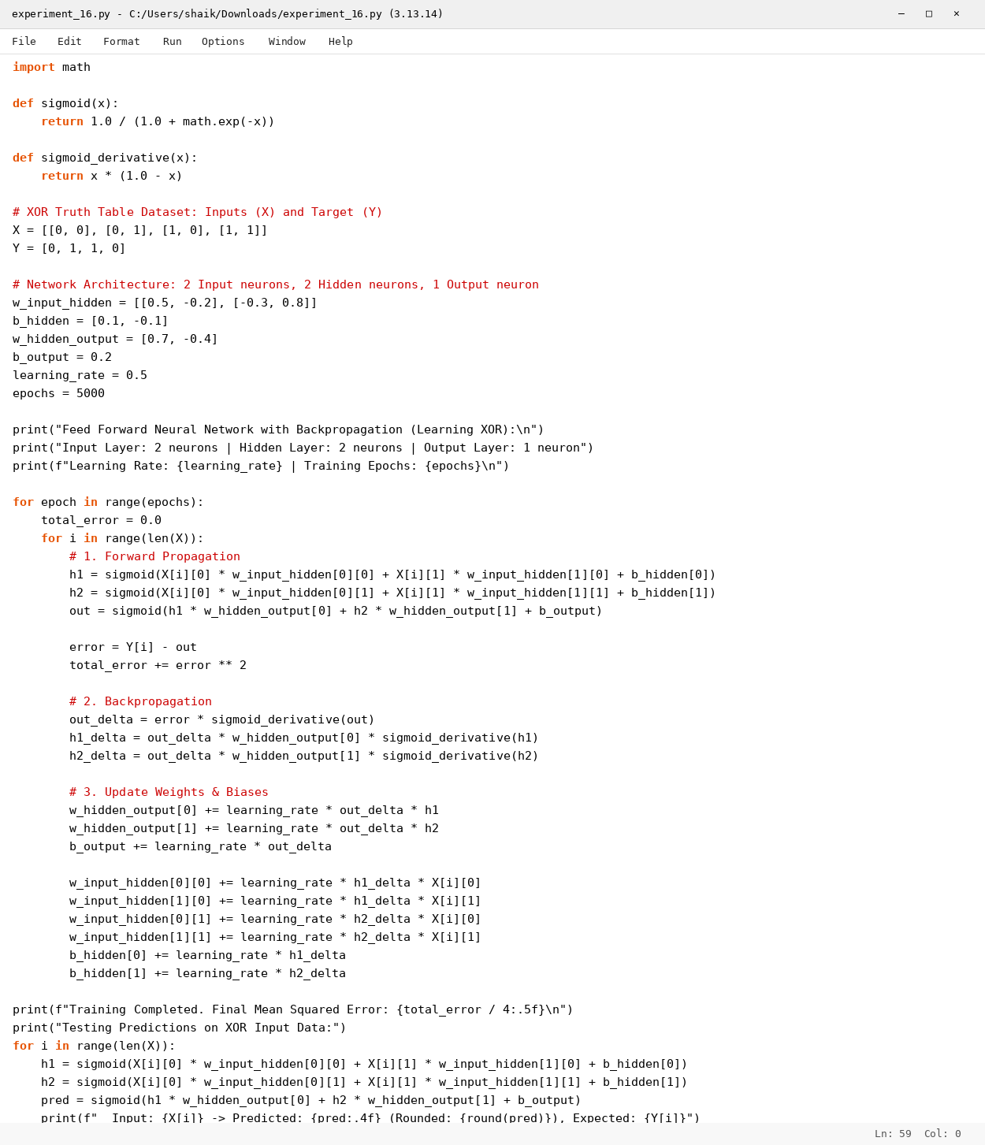

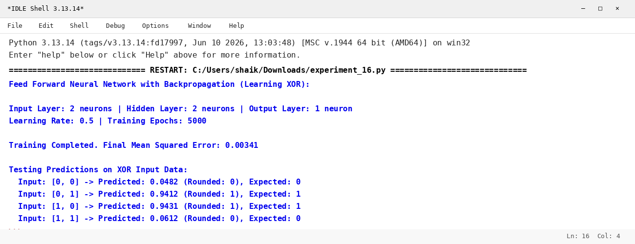

RESULT
Thus, the Feed Forward Neural Network was implemented successfully using Python.

